FORMAT FOR PARTICULARS OF STAFF TO BE SUBMITTED TO THE NRC, NCTE,JAIPUR

P A R T I C U L A R S O F S T A F F

Session ______2015-16______

Name and address of the Institution: SRI GURU TEG BAHADUR COLLEGE OF EDUCATION, KHANKOT,AMRITSAR Course:__B.Ed.
Sl. No. | Name with Date of Birth  Age | Attested photograph of the appointed staff | Whether SC/ST/OBC/other Category | Designation | B.Ed. Yes/No | M.Ed. Yes/No | M.A (Educati on) Yes/No | Master’s Degree in school subject Yes/No | Subject of Teaching | Ph. D. (Education/ Specify the subject) Yes/No | Passed UGC NET or equivalent Yes/No | Teaching Experience in Years | Teaching Experience in Recognized School/BEd. College (Enclose experience certificate from the Principal) | Date of initial appointment and NCTE Regulation under which he or she was appointed | Joining Date
 |  |  |  |  | If yes, %age of Marks | If yes, %age of Marks | If yes, %age of Marks | If yes, %age of Marks & specify the subject
(1) | (2) | (3) | (4) | (5) | (6) | (7) | (8) | (9) | (10) | (11) | (12) | (13) | (14) | (15) | (16)

I. | DETAILS OF TEACHING STAFF
I(A) | PRINCIPAL/HOD
I | Dr. Punam Chopra  Dcember 28, 1964 | 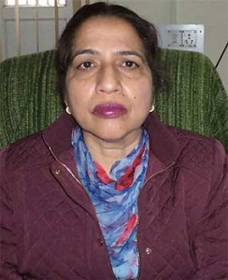 | - | Principal | Yes | Yes |  | No | Yes | English | Yes  (Education) | Yes | 13 yrs. 8 mths. | 11 years 2 months | 14/11/15 | 18/11/15
 |  |  |  |  | 60.7 | 64.5 |  |  | 55
II | LECTURES/TEACHING STAFF (AS PER NCTE NORMS)
 | Mrs. Vanita Sharma  January 26,1982  32 yrs. |  | - | Asstt. Professor | Yes | Yes | No |  | Yes | Economics | No | Yes | 6 yrs. 6 mths. | 20/09/07  To till date | 19/09/07 |  | 20/09/07
 |  |  |  |  | 67.5 | 70.6 |  |  | 63
 | Mrs. Kawalbir Kaur  July 23,1979  35 yrs. | 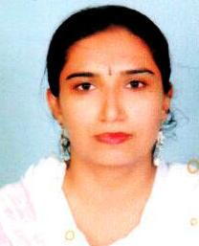 | - | Asstt. Professor | Yes | Yes | No |  | Yes | Mathematics | No | Yes | 6 yrs. 6 mths. |  | 06/07/08 |  | 18/08/08
 |  |  |  |  | 54.5 | 62.6 |  |  | 55.9
 | Mrs. Sarbjit Kaur  July 24, 1975  39 yrs. | 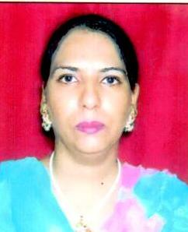 | - | Asstt. Professor | Yes | Yes | No |  | Yes | Punjabi | No | No | 7 yrs  4mths |  | 20/07/08 |  | 18/08/08
 |  |  |  |  | 62 | 59 |  |  | 56
 | Ms. Meenu Choudhary  April 18,1982  32 yrs. | 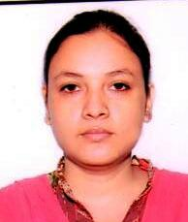 | - | Asstt. Professor | Yes | Yes | No |  | Yes | History | No | Yes | 6 yrs. 6 mths. |  | 04/06/11 |  | 04/06/11
 |  |  |  |  | 66.7 | 67.3 |  |  | 55.7
 | Mrs. Namreta Panju  April 22, 1981  33 yrs. |  | - | Asstt. Professor | Yes | Yes | No |  | Yes | Commerce | No | Yes | 4 yr  9 mths |  | 31/05/10 |  | 17/06/10
 |  |  |  |  | 74.6 | 67.8 |  |  | 63.7
Cont. P/2

Page -2
(1) | (2) | (3) | (4) | (5) | (6) | (7) | (8) | (9) | (10) | (11) | (12) | (13) | (14) | (15) | (16)
 | S. Pardeep Pal Singh  January1,1977  37 yrs. |  | - | Asstt. Professor | Yes | Yes | No |  | English | No | Yes | 2 yr 5 mths |  | 25/10/11 | 01/11/11
 |  |  |  |  | 64.3 | 68.57 |  | 52.75
 | Mrs. Bhupinderjit Kaur Randhawa  October 8, 1966  48 yrs |  | - | Asstt. Professor | Yes | Yes | No | Yes | Chemistry | No | Yes | 1 yr |  | 20/08/13 | 20/08/13
 |  |  |  |  | 56.54 | 63.28 |  | 60.7

